**HALF DAY TOUR ORONGO**

This tour delights both for its history and for the magnificent views offered by one of the most beautiful and deep volcanoes in all of RAPA NUI. The tour begins at the VINAPU archaeological site, whose stone constructions demonstrate the natives' techniques for working volcanic rock. In addition, there are several remains of destroyed moais, which were demolished in the 18th century during internal wars between clans. The journey continues in the ceremonial village of ORONGO, where the Tangata Manu competition was held, which in the local language means “Bird Man”, which determined which clan would be in charge of the island for a year. The route culminates at the RANO KAU Volcano viewpoint, which hides a true nature sanctuary in its surprising crater.

***The tour does not include a visit to the Ana Kai Tangata cave due to the danger of possible landslides.

**TIME: 09.00 HRS**

**DURATION: 3 HOURS**

**INCLUDES: GUIDE**

**RESTRICTIONS: NONE**

**ANAKENA FULL DAY TOUR**

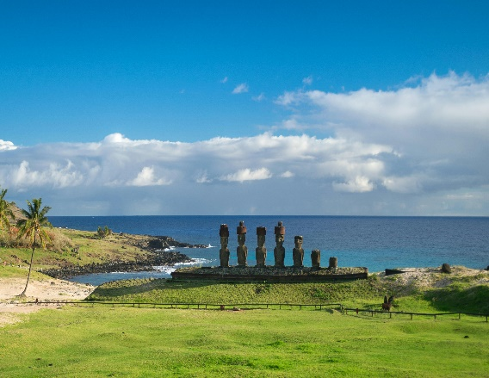

This archaeological trip covers some of the most amazing places that are related to the mysterious moais of the island. The tour begins with AHU AKAHANGA, an area of ​​recumbent moais and legends that say that the first king of the island was buried here. Continue the adventure by visiting RANO RARAKU, the sacred place where most of these stone giants were sculpted, and learn about the enigmas hidden behind the transfer of these imposing masses to other parts of the island. The next destination is AHU TONGARIKI, which has 15 moais restored and erected in recent decades, which is also the perfect prelude to TE PITO KURA, a ceremonial center that houses the largest moai of all those built. Crown your tour by visiting HANGA RAU or TE ARIKI, better known as Anakena beach, with the best preserved moais on the entire island. Here you can also enjoy a moment of rest, contemplating and enjoying its beautiful beach with palm trees, white sand and turquoise water.

**TIME: 09.00 HRS**

**DURATION: 6 HOURS**

**INCLUDES: GUIDE**

**RESTRICTIONS: NONE**

**HALF DAY TOUR AKIVI**

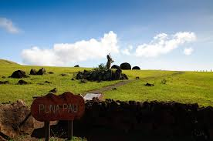

This tour is an adventure into the interior of the island. Be amazed by Rapanui history in the PUNA PAU quarry, where the headdresses of the best-known moais, such as Pukao, were carved. Continue towards a special platform called AHU AKIVI O ATI ´U, a restored sector that has seven moais of equal dimensions that face the sea, which align themselves at the sunset during the spring equinox and turn their backs on it at sunrise. during the autumn equinox. The tour ends at the TAHAI ceremonial center, a place that concentrates various archaeological and other contemporary components. Here you can see three restored platforms: AHU TAHAI, AHU VAI URI and AHU KO TE RIKU.

**TIME: 15.00 HRS**

**DURATION: 3 HOURS**

**INCLUDES: GUIDE**

**RESTRICTIONS: NONE**