**CITY TOUR PUERTO MONTT – PUERTO VARAS**

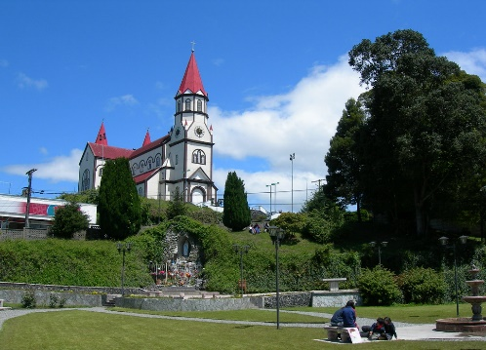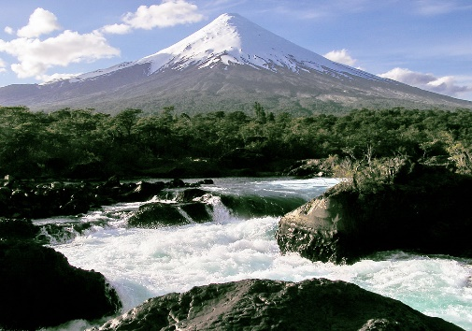

We will begin the tour from the beautiful city of Puerto Varas, also known as the City of Roses, with a stop at the waterfront to appreciate the view of the city from the bay and the “Aurora” sculpture with Lake Llanquihue in the background.

We will get to know its main tourist attractions; The Church of the Sacred Heart of Jesus (depending on opening availability), built between 1915 and 1918, in the Monumental Baroque style, is an exact replica of a Church in the Black Forest of Germany, where some settlers who arrived in our area came from. starting in 1852. We will visit the Old Quarter, where the first German settlers settled.

Then we will descend towards the central sector bordering the beautiful Llanquihue Lake and as a backdrop we will see, if the weather permits, the imposing Osorno Volcano which with its thaw feeds Lake Llanquihue every day.

Departure to Puerto Montt, 20 km to the South, Capital of the Lakes and Volcanoes Region, visiting the highest point of the city, from where we will have a beautiful panoramic view of the Pacific Ocean and Tenglo Island.

From there we will go to the Monument to the German Settlers, located in front of the Plaza de Armas, the waterfront pier, enjoying its architectural heritage and mix of cultures along the way. Subsequently, we will continue towards the Angelmó sector, famous in our country for its large number of Craft Shops and, of course, the Fisherman's Cove where we will learn about the daily activity of the seafarers who come to this place bringing traditional seafood. and fish, to then be sold in the Market, we will also find the typical kitchens where the most delicious and traditional typical dishes that characterize our area are sold.

**TIME: AM 09.30 / PM 15.30 HRS**

**DURATION: 4 Hours**

**INCLUDES: English guide**

**RESTRICTIONS: Excursions apply to and from Central Hotels Puerto Montt – Puerto Varas. Excursions may undergo date and time changes. Museums are not open on Mondays.**

**FRUTILLAR**

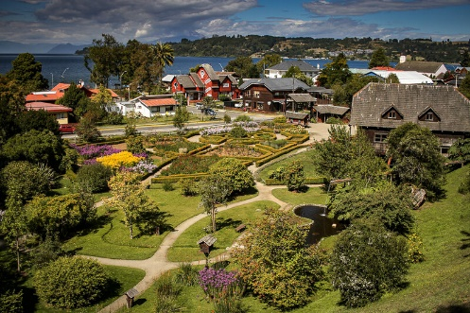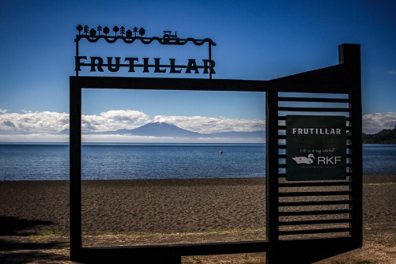

We will begin our excursion, visiting the city of Llanquihue, famous for its cured meats and the place of origin of the Maullín River, it is part of the old Colonos' Route. In the city we will visit Los Cisnes Beach and the Pier that has a beautiful view of the Lake and the Volcanoes. Then we will border Lake Llanquihue to head towards Frutillar.

We arrived at this city which is a beautiful town reminiscent of Bavaria, where its first settlers came from. It emerged in 1856 as a shipping dock, with tanneries, mills, breweries, etc. soon appearing. We will walk around its beautiful old German-style houses, admiring its well-kept gardens and its incomparable view of the Osorno and Puntiagudo volcanoes. Optionally, passengers can access the German Colonial Museum that shows the life of the settlers or enjoy a coffee with a German pastry typical of this area.

On its Costanera we will observe the Teatro del Lago where the famous “Frutillar Musical Weeks” are held annually with worldwide attendance.

**TIME: AM 09.30 / PM 15.30 HRS**

**DURATION: 4 Hours**

**INCLUDES: English guide**

**RESTRICTIONS: Excursions apply to and from Central Hotels Puerto Montt – Puerto Varas. Excursions may undergo date and time changes. Museums are not open on Mondays.**

**FRUTILLAR – PUERTO OCTAY**

We will begin our excursion, visiting the city of Llanquihue, famous for its cured meats and the place of origin of the Maullín River, it is part of the old Colonos' Route. In the city we will visit Los Cisnes Beach and the Pier that has a beautiful view of the Lake and the Volcanoes. Then we will border Lake Llanquihue to head towards Frutillar.

We arrived at this city which is a beautiful town reminiscent of Bavaria, where its first settlers came from. It emerged in 1856 as a shipping dock, with tanneries, mills, breweries, etc. soon appearing. We will walk around its beautiful old German-style houses, admiring its well-kept gardens and its incomparable view of the Osorno and Puntiagudo volcanoes. Optionally, passengers can access the German Colonial Museum that shows the life of the settlers or enjoy a coffee with a German pastry typical of this area.

On its Costanera we will observe the Teatro del Lago where the famous “Frutillar Musical Weeks” are held annually with worldwide attendance.

From here we will go to Puerto Octay, also located on the northern shore of the lake, marked by German influence and the first port for agricultural products to Osorno. We will walk through its old streets and Plaza de Armas

**TIME: AM 09.30 / PM 15.30 HRS**

**DURATION: 4 Hours**

**INCLUDES: English guide**

**RESTRICTIONS: Excursions apply to and from Central Hotels Puerto Montt – Puerto Varas. Excursions may undergo date and time changes. Museums are not open on Mondays.**

**OSORNO AND PETROHUÉ VOLCANO**

We will begin our excursion from Puerto Varas “the city of Roses” towards the Osorno Volcano, bordering Lake Llanquihue we will enjoy a beautiful postcard with the snow-capped Osorno and Calbuco volcanoes in the background, until we reach the Ensenada sector from where we will begin the ascent until we reach the Osorno Volcano SKI and Mountain Center, located at 1,240 meters above sea level.

We will be there for about an hour where there will be time to enjoy the landscape, take photographs, and appreciate an unparalleled view of the summit of the volcanoes with their eternal snow glaciers, Calbuco, Lake Llanquihue and the Pacific Ocean.

Optionally, passengers can serve themselves a coffee or sandwich at the on-site cafeteria or take the lifts to ascend to 1,450 meters high at the Spring Station or 1,750 meters at the Glacier Station from where a wonderful and impressive view can be seen. of Lake Llanquihue.

We will begin the descent towards the Ensenada sector where we will have time to make our Stop to enjoy a delicious lunch (not included).

Departure to Los Saltos de Petrohué, where paying access to the National Park, we will appreciate one of the most iconic sites in the sector, the “Saltos del Petrohué” viewpoint, a place where the river (of the same name) appears among large masses of crystallized lava, immune for centuries to erosion and formed by smaller stones joined by a glassy material that stands out to the eye, a must-see place. (This tour lasts

We head towards the Port of Petrohué, located on the shores of Lake Todos los Santos. Optionally, within the time stipulated in this sector, you can take a 30-minute navigation through the bay of the Lake (not included) or take a gentle walk along the shore of the Lake, all surrounded by an evergreen forest, the majesty of the Osorno Volcano. and the spectacular turquoise color of the Petrohué River.

**TIME: 09.00 HRS**

**DURATION: 8 Hours**

**INCLUDES: English guide**

**RESTRICTIONS: Excursions apply to and from Central Hotels Puerto Montt – Puerto Varas. Excursions may undergo date and time changes. Museums are not open on Mondays.**

**CHILOÉ ISLAND: CASTRO AND DALCAHUE**

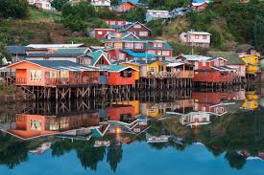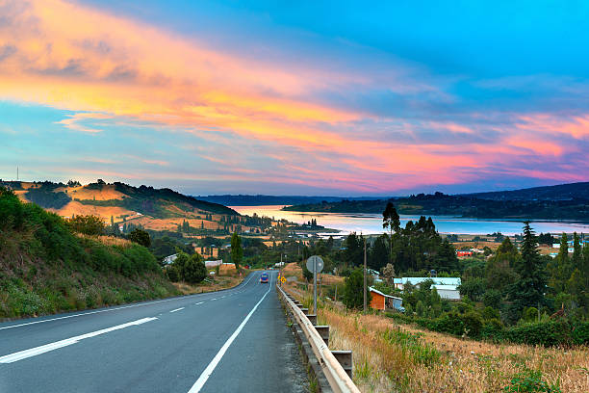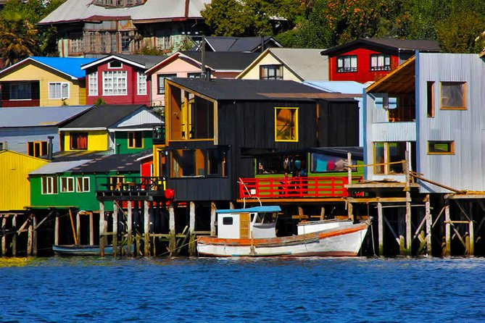

We will begin our excursion on the way to the town of Pargua, south of Puerto Varas, a place from where we will board a ferry to navigate through the Chacao Channel, which separates the continent from the Big Island of Chiloé. During navigation we will be able to observe sea lions, pelicans and marine birds typical of this region.

We will dock in the town of Chacao, where we can see typical Alerce wood constructions and also the San Antonio de Chacao church, and then continue our journey along the inland sea route, the western route of the island, which will take us to the town of Chacao. Quemchi.

Arrival in Quemchi, where we can visit its beautiful Costanera, which the writer Francisco Coloane baptized as the commune of 1000 landscapes. Later we will go to a wonderful place; Aucar, the Island of Navigating Souls which we can enter through a 430 meter wooden bridge.

Later we will head towards Dalcahue (a city located in front of the Island of Quinchao) and which on its waterfront has a gastronomic and craft market with a spectacular view. We will visit the Fair and walk towards the Nuestra Señora De Los Dolores Church, a typical Chilote construction that is part of the World Heritage Site.

Later we will continue our trip to the city of Castro, capital of the Big Island of Chiloé; Stopping to take photographs at the Palafitos (houses where the pillars are arranged over the water), we will visit the San Francisco Church in front of the city square and its Crafts Market.

**TIME: 09.00 HRS**

**DURATION: 12 Hours**

**INCLUDES: English guide**

**RESTRICTIONS: Excursions apply to and from Central Hotels Puerto Montt – Puerto Varas. Excursions may undergo date and time changes. Museums are not open on Mondays**

.

**CHILOÉ ISLAND: ANCUD AND PINGUINERAS OF PIÑIHUIL**

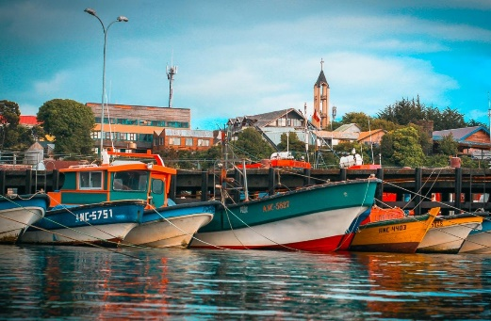 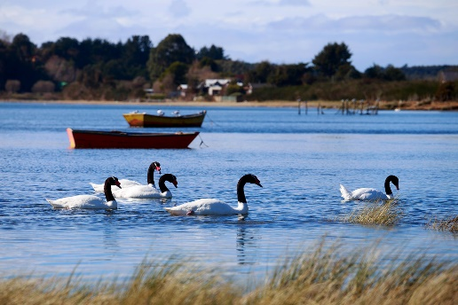

We will begin our excursion on the way to the town of Pargua, where we will board a ferry to navigate through the Chacao Channel, which separates the continent from the Big Island of Chiloé. During the navigation (45 minutes) we will be able to observe sea lions, pelicans and marine birds typical of this region.

We will dock in the town of Chacao, where we can see typical Alerce wood constructions and also visit the San Antonio de Chacao church. After this we will continue towards the Caulin sector, where there is an intertidal wetland that allows the feeding of different types of birds throughout the year such as Black-necked Swans, Herons and Flamingos (the latter in winter periods).

We will arrive at Puñihuil beach, where we will board a boat that will take us to the islets where the Magellanic and Humboldt Penguins are found (40 minutes of navigation, tkt not included). It should be noted that it was declared a National Monument due to its ecological importance.

We will arrive at the city of Ancud, where we can visit the Local Museum, the Municipal Market and the San Antonio Fort; historic site located in the upper part of the city, built at the end of the 18th century and which is part of one of the last Spanish fortifications in our country.

Arrival at the Hotel

**TIME: 09.00 HRS**

**DURATION: 12 Hours**

**INCLUDES: English guide**

**RESTRICTIONS: Excursions apply to and from Central Hotels Puerto Montt – Puerto Varas. Excursions may undergo date and time changes. Museums are not open on Mondays. Navigations subject to Weather Conditions, prior Authorization from the Maritime Government**

**ANDEAN LARCH PARK**

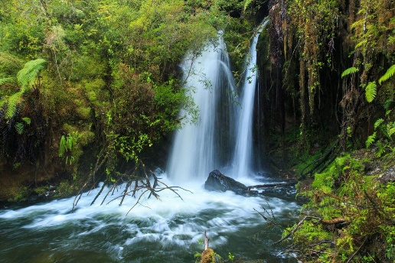

Departure in the direction of Puerto Montt, where we will take Route 7 that will take us to the Lenca sector and we will detour along a 7 km internal road to the entrance of the Park.

Arrival at the Park and here after paying the entrance fee (not included) we will begin our walk accompanying the Salto Rio Chaicas Trail, which will accompany us with its crystalline waters and the sound of its torrent that, together with nature with its different shades of green, They will leave photography lovers amazed as we progress.

We will also have the possibility of seeing different types of birds such as the Chucao, Hummingbirds, Woodpeckers, among others. We will reach a staircase that takes us to the Chaicas River Falls, a beautiful waterfall where we will see the pure and transparent water dancing between the rocks. We will have time to rest while we admire this spectacle of nature. About 100 meters higher we will climb the last section that takes us to the mythical Alerce Milenario, where our gaze slowly goes towards the sky to see its crown that touches the rays of the sun. After this we return along the same path towards the park ranger booth and return to the Hotel.

**TIME: 09.00 HRS**

**DURATION: 12 Hours**

**INCLUDES: English guide**

**RESTRICTIONS: Excursions apply to and from Central Hotels Puerto Montt – Puerto Varas. Excursions may undergo date and time changes. Museums are not open on Mondays.**

**THERMAL SUN**

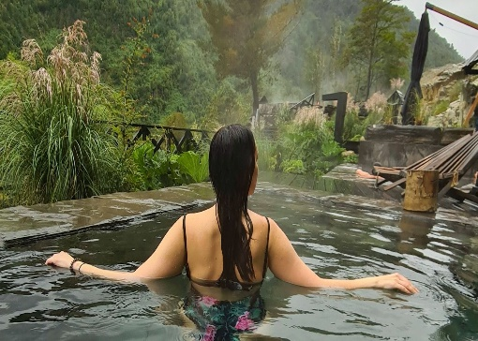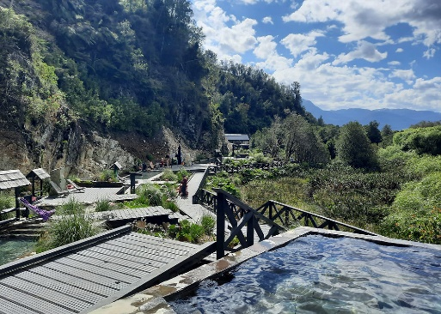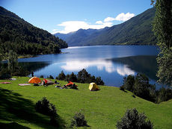

We begin our tour along route V-69, where we can see the exuberant native vegetation, a fabulous landscape accompanying the slopes of the Reloncavi Estuary.

We will arrive at Termas del Sol, a beautiful thermal spring, where each pool is unique for its temperature and shape, all of them built in stone. Its temperatures vary between 36º and 45º, and arise from a 60º hot spring. After paying the entrance fee (not included) the path will take us through a small forest to reach the facilities where we will use the changing rooms so we can use the pools themselves. Within these facilities there is also a cafeteria with sandwiches, soups and drinks to consume (not included).

Return to Puerto Varas, where we will stop at the Puente del Rio Puelo and the town of Cochamó where we will appreciate its church and waterfront.

**TIME: 08.30**

**DURATION: 12 HOURS**

**INCLUDES: TRANSFER ONLY**

**RESTRICTIONS: Not allowed for pregnant women. Minimum required age of 3 years.**

**FULL DAY PEULLA**

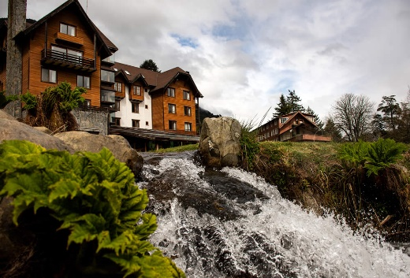 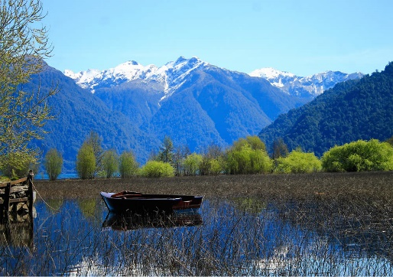

Departure from the Puerto Varas office by bus to Petrohué, bordering Lake Llanquihue.

Panoramic view of the Osorno and Calbuco Volcano that dominate the entire landscape. Entrance to the Vicente Pérez Rosales National Park. Visit to the Petrohué Falls

From the port of Petrohué we will set sail towards Peulla, sailing the Todos los Santos Lake. If the weather permits, new views of the Osorno Volcano, Puntiagudo Volcano and Cerro Tronador will surprise us.

Arrival in Peulla, ecological village, paradise for nature lovers. Lunch at Hotel Natura Patagonia. (additional cost as applicable).

Free afternoon in Villa Peulla, to carry out ECO-Tourism activities.

In the afternoon we return from Villa Peulla, sailing the Todos Los Santos Lake to Petrohué - Puerto Varas.

**TIME: 07.30 HRS**

**DURATION: 8 HOURS**

**INCLUDES: ROUND-TRIP NAVIGATION, TICKETS AND LUNCH AS APPROPRIATE**

**RESTRICTIONS: NO RESTRICTIONS.**