**CITY TOUR PUNTA ARENAS**

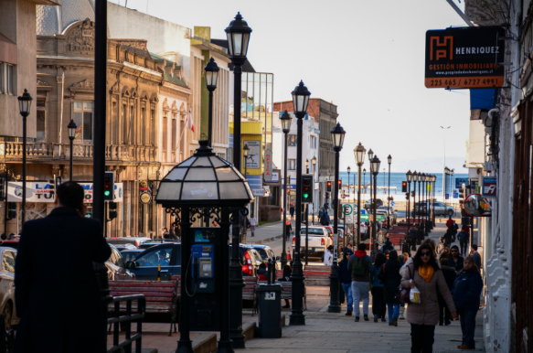  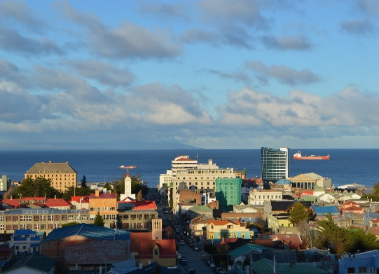

Discover Punta Arenas, its history, and its most emblematic points. We will begin the City Tour with a visit to Cerro de la Cruz, a spectacular viewpoint that offers unparalleled panoramic views of the city, the Strait of Magellan and Tierra del Fuego. Then we will tour the Plaza de Armas Muñoz Gamero, the vibrant heart of the city since the late 19th century, which stands out for its neoclassical architecture that surrounds it, we will see the Monument to Hernando de Magallanes, and the local souvenir stands. We will have the option of visiting a museum: offering a deep immersion in local history and roots. Or to the Municipal Cemetery: a true national icon, recognized for its impressive beauty and meticulous care. We will end our tour with the monuments on the north side of the city, such as the Sheepdog Monument, the Croatian Immigrant Monument, and the Petroleum Monument, each of them telling an essential and most innate part of the history of our home.

**TIME: 10.00 AND 15.00 HRS**

**DURATION: 3 HOURS**

**INCLUDES: TRANSFER AND ENTRANCE TO THE MUSEUM**

**RESTRICTIONS: NO RESTRICTIONS**

**STRAIT PARK**

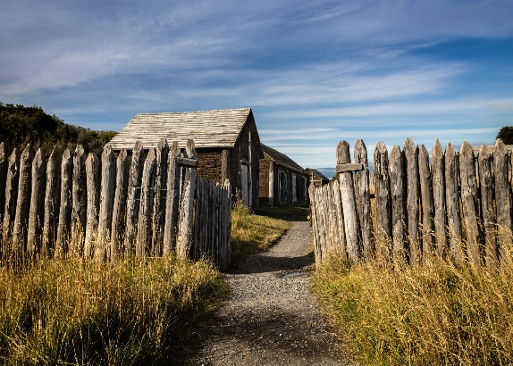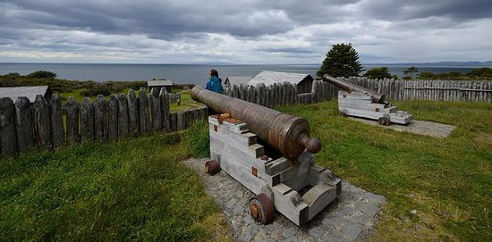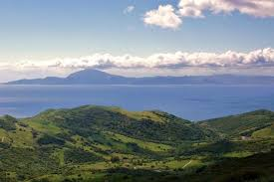

A journey through the natural and human history of the Strait of Magellan. 53 km south of Punta Arenas, with 130 hectares of forests surrounded by more than 5 km of coast, this park houses important historical points of the region. Visit the main sites of interest in the park: The visitor center, Fuerte Bulnes (National Historical Monument), Mirador del Estrecho, multiple trails, the towers, and Puerto del Hambre (National Historical Monument). The route borders the mythical Strait of Magellan, where it is possible to see a large number of seabirds, such as oystercatchers, wild geese, several species of ducks, cormorants, and on a lucky day, there is the possibility of seeing dolphins and sea lions.

**TIME: 09.00 HRS**

**DURATION: 5 HOURS**

**INCLUDES: SHARED TRANSPORTATION**

**RESTRICTIONS: DOES NOT INCLUDE TICKET**

**TREKKING MAGALLANES RESERVE**

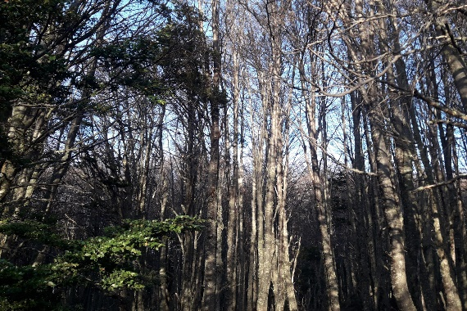 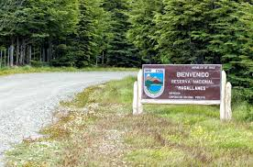 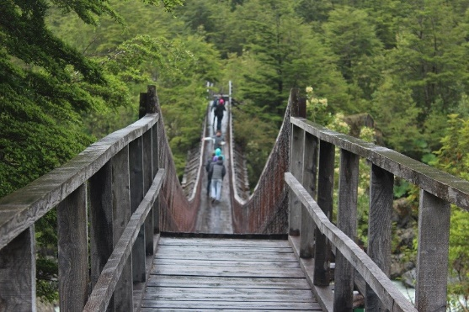

This half-day excursion allows you to get to know the Magallanes National Reserve, a forested protected area with multiple trails enabled for trekking and mountain biking. The reserve is located just 8 km west of the city of Punta Arenas and has an area of ​​20,878 hectares. At the beginning of the excursion we will cross different neighborhoods to the south of the city, soon taking a paved road that leads us to the reserve. Once there we must take a 4 km path, surrounded by the Patagonian forest that is increasingly present on the way, to reach the park ranger's booth and carry out our Check In. We will begin the trail for a walk of about half an hour, during the walk we will be able to appreciate different species of flora such as romerillo, sarsaparilla, strawberry, calafate, murtilla, notro, lendura, michay, and coigüe and lenga forests. Among the bird species it is possible to see chunchos, pintails, chercanes, cachañas, chincoles, cometocinos, thrushes, and tiuques. From the trail we will also have a panoramic view of the Río de las Minas valley and its path to the Strait of Magellan. The return to Punta Arenas is done by the same route.

**TIME: 09.00 HRS**

**DURATION: 3 ½ HOURS**

**INCLUDES: SHARED TRANSPORTATION**

**RESTRICTIONS: ONLY OPERATES FROM SEPTEMBER TO APRIL**

**DOLPHIN WATCHING IN BAHIA AGUA FRESCA**

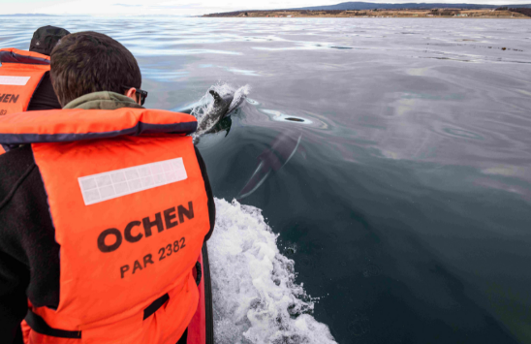 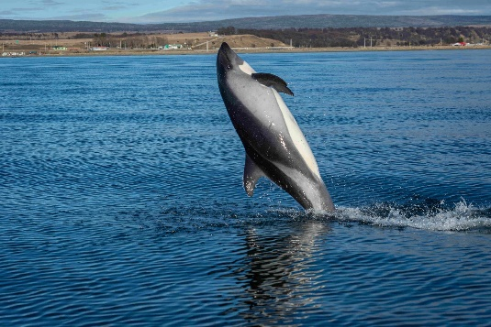 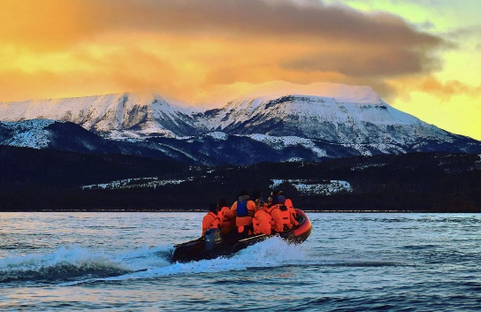

A few kilometers south of Punta Arenas, there is a bay whose seabed is covered by seaweed forests, which create the natural habitat for feeding numerous groups of Southern Dolphins. Aboard a modern and safe boat, you will be able to circumnavigate and live the experience of being in a natural environment in its most pristine state. Given the clarity and purity of our southern seas, you will have the opportunity to rescue beautiful photographs and unforgettable memories.

**TIME: 07.00 HRS**

**DURATION: 2 HOURS**

**INCLUDES: SHARED TRANSPORTATION**

**RESTRICTIONS: NO RESTRICTIONS**

**LAND OF FUEGO AND KING PENGUIN**

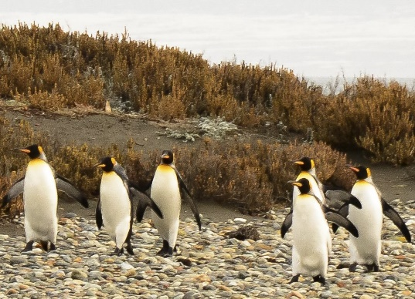 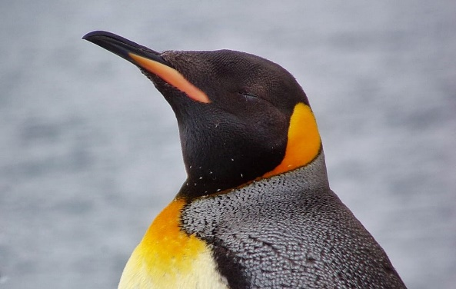 

The morning begins by heading to the Tres Puentes terminal, where we will board a 2-hour ferry that crosses the Strait of Magellan, a historic 583 km long channel that connects the waters of the Pacific Ocean with the Atlantic, stopping in Tierra del Fuego and heading to Porvenir, the most important city in Tierra del Fuego, where we will have a delicious lunch to start the day. After lunch, we will continue the road bordering Bahía Inútil, crossing the island that surprises with its endless pampas and its horizon that projects to infinity. Along the way we will be able to see various birds, sheep ranches, and herds of guanacos, a South American camelid related to the llama and the alpaca. After about 114 km, we will arrive at the King Penguin Park, home to a permanent colony of this species, it is the largest species of penguin after the emperor penguin. We will leave the park heading towards Primera Angostura, the narrowest point of the strait, only 5 km wide. There we will cross back to the continent on a ferry that takes 20 minutes, after which we will take a route of about 200 km. until reaching Punta Arenas.

**TIME: 07.00 HRS**

**DURATION: 11 HOURS**

**INCLUDES: TRANSPORTATION, GUIDE**

**RESTRICTIONS: DOES NOT INCLUDE FOOD OR ENTRANCE**

**MAGADALENA ISLAND NAVIGATION**

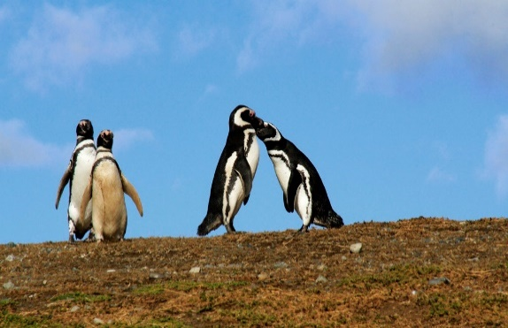 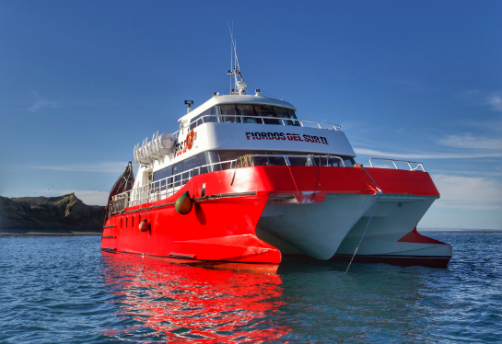 

Sail on a comfortable catamaran to Magdalena Island, where you will visit the Los Pingüinos Natural Monument and the Magdalena Lighthouse, located in the middle of the Strait of Magellan. Begin with this unique adventure by checking in at Avenida Colon Nª 842, and then embark on a fast Catamaran for one hour and 30 minutes to Magdalena Island, one of the largest colonies of Magellanic penguins in South America. In the place we will also be able to spot Black-browed Albatrosses, Skuas, Terns, Cormorants, and Dominican Gulls in the surrounding skies. After visiting the island for 1 hour, the return to Punta Arenas begins, where you will have the opportunity, if luck is with us, to spot Southern Dolphins, Overas Dolphins and Sei Whales. Without a doubt an unparalleled trip.

**TIME: 07.00 HRS**

**DURATION: 4 1/2 HOURS**

**INCLUDES: CATAMARAN EXCURSION, GUIDE, ENTRANCE**

**RESTRICTIONS: OPERATES IN OCTOBER AND MARCH**

**CITY BIKE**

Touring the city and learning about its history by bicycle transforms this activity into an excellent half-day panorama. We will meet our guide at the agreed time to receive instructions and check our equipment. We will begin our excursion from our office located at Manuel Bulnes 407, Puerto Natales, a few meters from the Plaza de Armas.

Puerto Natales is located on the banks of the Señoret Channel, between the Almirante Montt Gulf and the Ultimo Esperanza Sound, being the capital of the province that bears the same name (Última Esperanza). A name that has its origin in the first explorations carried out by the navigator Juan Ladrillero during his incessant search for a route to the Strait of Magellan.

During the excursion we will learn about the ancient aborigines who populated the extensive territories as well as relevant background information about the first explorations of the area that promoted settlement in the province. We will visit various monuments, streets and avenues of the city. We will tour the waterfront, the main viewpoints, pioneer houses, the Etherh Aike artisan village, the plaza of the four towns, Braun & Blanchard Pier, mural of native peoples and the Arturo Prat Plaza de Armas. The tour concludes in the same place where the tour began.

**TIME: 15.00 HRS**

**DURATION: 3 HOURS**

**INCLUDES: BIKE, HELMET AND GUIDE**

**RESTRICTIONS: DOES NOT OPERATE ON DECEMBER 25 AND JANUARY 1**

**HISTORICAL CITY TOUR**

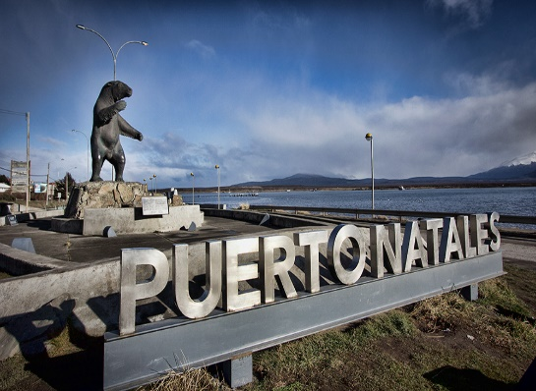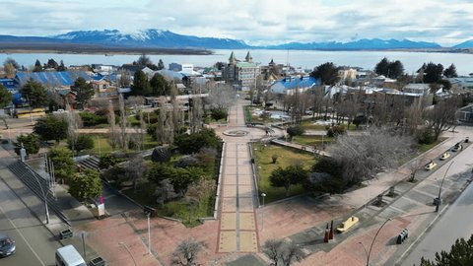

A beautiful half-day excursion to understand the origin and why of Puerto Natales, learn about the toponymy of the environment that surrounds this century-old city, its history and little-known details. Admire and contemplate the coast of the Señoret channel with the mountains that surround it. In 1894, German pioneers Ernest von Heinz and Kurt Meyer named the river that flows into the northern part of the current city Natalis. This is because the sighting of the river occurred on December 24 on the eve of the commemoration of the birth of Christ, hence the name of the city. A tour that allows you to see the remodeled waterfront, main square, artisanal fishermen's pier, artisanal village, and the viewpoint of Santiago Bueras Avenue. From this privileged place you can observe the picturesque architecture of low, colorful houses covered with corrugated iron.

**TIME: 9:00 a.m. or 2:00 p.m.**

**DURATION: 4 HOURS**

**INCLUDES: PRIVATE TRANSPORTATION, GUIDE AND ENTRANCE TO THE MUSEUM**

**RESTRICTIONS: NO RESTRICTIONS**

**COCK PAINTING CERRO BENITEZ**

We will discover the traces of the past, we head north of Puerto Natales a little more than 25 km, we begin a day of exploration visiting the Archaeological Park located inside the Estancia Ernesto Helmer, a landscape that is born from the bottom of the sea and that today we can tour and observe its mountains, cracks, eaves and valleys. In the sector it is possible to access the perches of condors that dominate the skies in said place and once we reach the summit we will obtain a spectacular panoramic view of the Eberhard Fjord and Canal Señoret. Cerro Benítez is part of a paleontological sector that houses cave paintings that are approximately 3,500 years old. We will visit the window cave and then on the south east side we will enter the hidden cave (here we must access with headlamps and at the tip and elbow), this cave has an approximate height of 4 meters and its size is approximately 70 square meters we will be able to observe stalactive millennia that formed as a result of the accumulation of salts and minerals plus a constant drip of water, taking thousands of years to form. Once this exciting visit is over, leaving the cave we continue our walk in the direction of the eaves called “Two Horseshoes”, crossing lush forests, finally we can see cave paintings on the rock walls.

**TIME: 08.00 or 15.00 HRS**

**DURATION: 5 HOURS**

**INCLUDES: CANES, SHARED TRANSPORTATION**

**RESTRICTIONS: PICK UP DURING PM TIMES MAY VARY DURING THE WINTER SEASON**

**SARMIENTO GOALKEEPER**

An excursion that connects two of the four accesses that the Torres del Paine National Park has, allowing you to visit a little-known and very attractive perspective for observing wildlife. Its landscape environment is undoubtedly a place worth visiting. Upon entering the park through the Lago Sarmiento gate, we will begin our path with a gentle incline with a side view of the imposing Lake Sarmiento, adjacent to private lands, the usual hunting area for the largest predator in the region, the Puma. Species that finds its main food source in the Torres del Paine National Park, the Guanaco. After an hour of walking we will arrive at an overhang where it is possible to see a series of cave paintings dating back more than 6,000 years, a place frequented by groups of hunters known as one of the first populations to arrive in Patagonia. At this site we can photograph the surroundings and learn a little more about local history. The activity continues towards Laguna Blanquillos, a nesting and feeding place for different species of endemic Patagonian birds such as ducks, caiquens and black-necked swans, always with a frontal view of the Paine mountain range. After about 2 hours of walking we will reach the main access to the Torres del Paine National Park: Laguna Amarga gate. After a stop to use services, we will return to the vehicle to go to a little-known sector where the waters of the Paine River, coming from the Dickson Glacier, increase their flow with a high concentration of minerals and sediments. We are referring to the Paine Waterfall. In this place we will have free time to enjoy our box lunch with a frontal view of the granite towers among ñirre bushes. The day continues towards Cañadón Macho, an area where it is possible to observe large groups of guanacos that coexist with species such as the Rhea, Gray Fox, Condor, Black Eagle among others.

**TIME: 09.00 HRS**

**DURATION: 9 HOURS**

**INCLUDES: LUNCH BOX AND GUIDE**

**RESTRICTIONS: THIS TOUR DOES NOT OPERATE ON DECEMBER 25 OR JANUARY 1**

**FULL DAY TORRES DEL PAINE WITH MILODON CAVE**

Departure from your hotel to the Cueva del Milodón located 24 kilometers north of Puerto Natales. Before reaching the cave, the access road passes through the “Devil's Chair”, a name that comes from the popular imagination given to a rock structure that looks like an armchair which is said to have been the “seat” of Milodón and that the legend transformed into “devil.” At the end of the visit, we continue along the new access road to the Torres del Paine National Park, being able to observe lagoons and mountain ranges along the way. Next, it is possible to admire the beautiful landscape that surrounds us from the Lago Gray Viewpoint (view of the Gray Glacier, the Paine Massif and Lago del Toro). A couple of kilometers further on it is possible to see the Cuernos del Paine, reaching the fork that takes us towards the area of ​​Lago Gray. In this sector we can take a pleasant walk along the shore of Gray Lake and if the conditions help us, it is possible to access the Gray Peninsula viewpoint. Back at the Daycare parking lot, we resume the route to go to a restaurant located inside the park to take a moment of rest with the option of lunch. (Lunch not included in the rate). At the end of this restful rest, we begin the second stage of our visit to the Torres del Paine National Park, heading to the Salto Grande sector. We will visit the Nordenskjold Lake Viewpoint and continue enjoying various views on our undulating route that gradually brings us closer to the Laguna Amarga sector. After admiring this pleasant spectacle, we will return to the city of Puerto Natales passing through the Mirador del Lago Sarmiento, arriving at dusk and bringing with it an unforgettable experience.

**TIME: 07.00 HRS**

**DURATION: 10 HOURS**

**INCLUDES: SNACK AND GUIDE**

**RESTRICTIONS: DOES NOT INCLUDE TICKETS**

**TREKKING BASE LAS TORRES**

Departure from Puerto Natales at 07:00 am and direct transfer to Las Torres sector where we will arrive at “Cerro Paine Reserve”, the starting point of the trail. There we will receive a prior instructive talk from our guide. Start of the walk. We take the road towards the Valley and after 10 minutes of walking, we will walk over an old suspension bridge that crosses the Ascencio River. About 150 meters ahead, a fork appears: to the left it leads to the Las Torres Base. Then follows a zigzag with a steep slope and sparse vegetation for an hour. The ascent continues and passes next to another slope and after 45 minutes we reach Camping Chileno on the opposite bank of the Ascencio River, in the shadow of a beech forest, with a moderate slope, crossing several slopes that fall from the Almirante. Grandson. After about an hour and 10 minutes from the Chilean campsite, at 700 meters above sea level, you reach the foot of the moraine that gives access to the viewpoint. From this point, the trail increases its slope. First it goes next to a slope and under the shade of the small trees located at the edge of the moraine, but further up the path is lost as such and you must continue ascending among the rocks, some of which are marked to show the route. After about half an hour from the sign at 700 meters above sea level, you reach the eastern end of the lagoon, from where you have a wonderful view of the three towers (Central, Monzino, Dagostini) and the Peineta and Nido de Cóndores hills. After resting and having lunch in this extraordinary and unique scenic context on the planet, we begin our return along the same path until we reach the starting point, where our driver will be waiting to return to Puerto Natales at the end of the day.

**TIME: 07.00 HRS**

**DURATION: 12 HOURS**

**INCLUDES: BOX LUNCH, GUIDE**

**RESTRICTIONS: SUGGESTED MINIMUM AGE TO TAKE THIS TOUR 15 YEARS**

**BALMACEDA AND SERRANO GLACIER NAVIGATION**

The navigation begins by entering the Señoret channel, heading towards Guanaco Island, where it is sometimes possible to see the small and wonderful Magellanic Dolphins (Toninas). We navigate to the block of Estancia la Peninsula to access the rock walls where an important population of Cormorants lives, continuing the trip to Punta de Lobos where we find some specimens of said mammal. Then we visit the waterfall and cliffs where we can see condors. At each point of interest, the boat will stop so that travelers can enjoy the landscape and attractions. The trip continues towards Mount Balmaceda (2035 meters of altitude) where we can appreciate the glacier of the same name and then we will disembark in Puerto Toro to begin the one-hour round trip walk along the banks of the Témpanos lagoon, accompanied by our bilingual guide. . Through a native forest of coihues, ñirres and ciruelillos, heading to the Serrano glacier, we will enjoy the fascinating vegetation, the contrast between a clear sky and the ice of the imposing Serrano glacier. Our return begins, visiting a ranch, where we will enjoy a typical Creole lunch of the area. After having witnessed a unique, wild and virgin landscape, we end our excursion in Puerto Natales.

**TIME: 07.30 HRS**

**DURATION: 8 HOURS**

**INCLUDES: TRANSFER OFFICE – DOCK – OFFICE (SHARE), MARITIME TRANSPORTATION, BILINGUAL SPANISH/ENGLISH GUIDE**

**RESTRICTIONS: SEPTEMBER TO APRIL: EVERY DAY. DOES NOT OPERATE FRIDAY**

**GRAY GLACIER NAVIGATION**

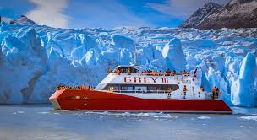

The Gray Glacier Navigation is one of the unmissable excursions if you visit the Torres del Paine National Park. This 3-hour journey takes place aboard the “Grey III” catamaran and allows us to enjoy an unparalleled landscape composed of floating icebergs, lush vegetation and imposing mountains.

To get to the boarding area we will need to take a 35 to 40 minute walk (1.5 km) from the parking area located on the banks of the Pingo River. We will cross a bridge over the river of the same name, walk through an ancient lenga forest and then continue along the width of “Grey Beach” to board the catamaran.

The Gray Glacier is part of the southern ice fields and is located in the western sector of the Torres del Paine National Park. It is a mass of ice approximately 6 km wide and a height that fluctuates between 20 and 30 meters. Its homonymous lake reaches a depth of more than 500 meters in some areas.

During the navigation we approach the different faces of the Glacier allowing us to observe the beauty and magnitude of this ice giant. Once the activity is over, we will have to make the same return journey to the parking lot.

**SCHEDULE: DEPARTURE FROM PUERTO NATALES 07.00 HRS – FIRST DEPARTURE 10.00 HRS**

**DURATION: 4 HOURS**

**INCLUDES: HOST ON BOARD AND APERTIVE**

**RESTRICTIONS: SEASON: MARCH TO OCTOBER MINIMUM 15 PASSENGERS**

**PERITO MORENO GLACIER**

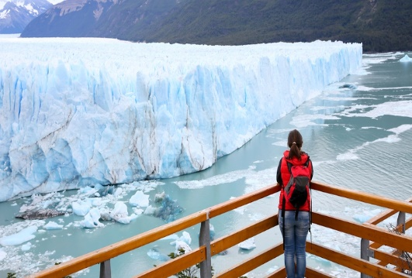 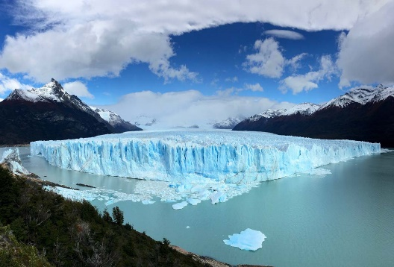 

At 06:30 hrs. The bus begins the pick up of travelers at their respective accommodation locations, beginning the trip towards Cerro Castillo, Rio Don Guillermo border crossing, where customs and immigration processing is carried out, officially entering Argentina. From there, the direct journey begins until reaching El Calafate. An Argentine Guide specially hired for the tour will board the bus. We continue the trip for 1 hour and a half more until we reach Los Glaciares National Park. Passengers will have the option of sailing on Lake Argentino on a catamaran (Navigation not included in Tarifa), which allows them to get closer to the front wall of the glacier, where it is possible to observe the constant ice falls of more than 70 meters. in height. Afterwards, it is possible to walk more than 3 kilometers of walkways in front of one of the most impressive glaciers in the world, the Perito Moreno Glacier. This tour lasts about an hour. We return to El Calafate, to make a thirty-minute stop (if the visit to the park is not delayed). Return to Puerto Natales at approximately 5:30 p.m. to arrive around 10:30 p.m.

**TIME: 06.30 HRS**

**DURATION: 16 HOURS**

**INCLUDES: SHARED TRANSPORTATION, LOCAL GUIDE**

**RESTRICTIONS: THE SECTION FROM PUERTO NATALES / LOS GLACIARES NATIONAL PARK (PERITO MORENO) HAS AN APPROXIMATE DURATION OF 7 HOURS, INCLUDING THE MIGRATION PROCESS.**