**CITY TOUR SANTIAGO**

Santiago, today a modern and cosmopolitan city, hides between the Andes Mountains and the Coastal Mountains a history full of anecdotes. We will tour historical, commercial and residential areas of Santiago, through which we will piece together the history of the capital of Chile. We will visit the Government Palace “La Moneda” and we will walk through part of the historic center, the Plaza de Armas, the Cathedral of Santiago, the Central Post Office and the Municipality. Then we will continue along the main avenue of the city, “La Alameda”, to reach Cerro Santa Lucía, the place where Pedro de Valdivia founded Santiago de Nueva Extremadura in 1541. There we will make a stop to walk through one of the “island hills”. most emblematic of the city. Later, we will continue towards Providencia and Las Condes, areas of modern commercial and residential constructions. We will pass by the Costanera Center and its 300-meter skyscraper, the tallest in South America, to continue through the El Golf neighborhood to residential sectors that reach the foot of the Andes Mountains.

**TIME: 09:00 or 14:00 hrs.**

**DURATION: 4 HOURS**

**INCLUDES: TRANSPORTATION**

**RESTRICTIONS: NO RESTRICTIONS**

**VIÑA DEL MAR Y VALPARAISO**

We will leave from the hotel towards the Pacific coast, crossing the fertile valleys of Curacaví and Casablanca. Upon arrival, you can see the city of Valparaíso and the National Congress from the coastal road, and then go up to its most iconic viewpoints located on one of the 43 hills that surround the bay, we will walk through its passages, stairs and alleys, full of urban art, street musicians, small restaurants, cafes and boutique hotels, where we will also be captivated by its picturesque elevators. The historic center of this port city was declared a World Heritage Site for its architecture that gives it a marked personality and enhances its tourist attraction that will undoubtedly delight you. Then we continue to the neighboring spa city of Viña del Mar, where we will first give you time to have lunch with an incredible view of the Pacific Ocean (Optional). Viña del Mar is famous for its gardens, where the Flower Clock is its symbol. We will pass by the Games Casino, we will visit the Quinta Vergara, famous for the Viña del Mar Festival and for the residential sectors, with modern architecture. Then we will continue to Reñaca beach to appreciate the sea and one of the most touristic beaches in Chile.

**TIME: 08:30 hrs.**

**DURATION: 8 HOURS**

**INCLUDES: TRANSPORTATION**

**RESTRICTIONS: NO RESTRICTIONS**

**CONCHA Y TORO VINEYARD**

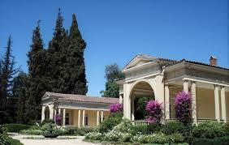 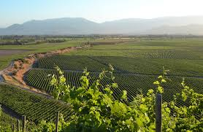 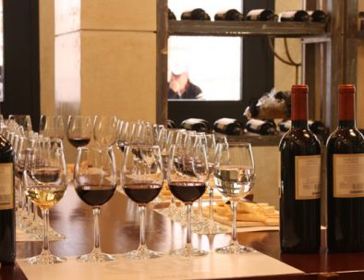

Departure from the hotel heading towards the south of the city to approach a mountain area. The trip continues towards the valley known as the Cajón del Maipo, a rural area in which the landscape, the mountains and the small crops of vines and fruits come together. There we arrived at the renowned Viña Concha y Toro. We visit the park of ancient trees, its vineyards and the traditional wineries of this historic place, while we learn the process and preparation of the main product.

Chilean exporter. Here we will immerse ourselves in the corner that keeps one of the best kept secrets of the vineyard: “El Casillero del Diablo”. The tour ends with a tasting and the glass we used will remain with us as a souvenir of this experience. We will have time to buy wines in the store and then return to the hotel.

**TIME: 9:00 a.m. or 2:00 p.m.**

**DURATION: 4 HOURS**

**INCLUDES: TRANSFER AND TASTING IN THE VINEYARD**

**RESTRICTIONS: THE ENTRY OF PETS TO THE VINEYARD FACILITIES IS PROHIBITED. EL VIEÑDO DOES NOT HAVE UNIVERSAL INCOME ACCESS TO BODEGA CASILLERO DEL DIABLO, SINCE DUE TO THE AGE OF ITS CONSTRUCTIONS IT IS NOT POSSIBLE TO INTERVENE. THE REST OF THE FACILITIES DO HAVE THIS ACCESS**

**FARELLONES AND SKI CENTERS**

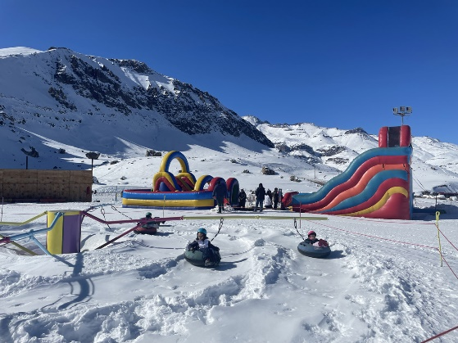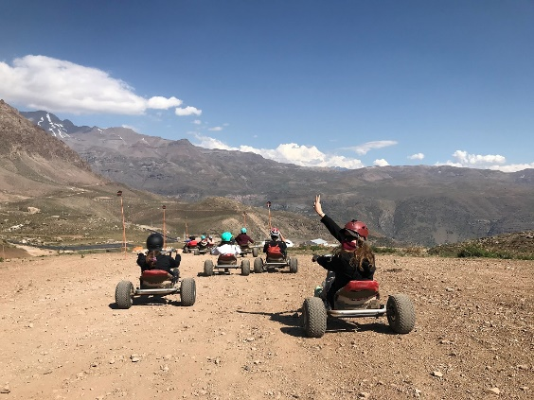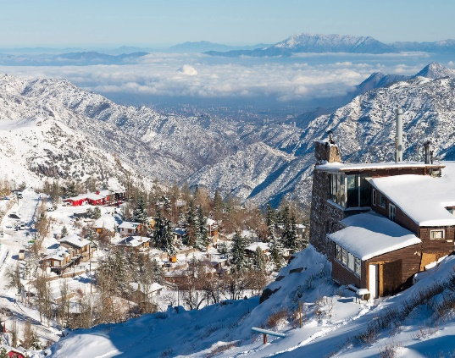

The excursion begins by leaving the hotel to head towards the eastern sector of Santiago. We will pass through the residential neighborhoods of Las Condes and El Arrayán until we reach a winding road that will take us into the heart of the Andes Mountains. We will appreciate all its magnitude and its curious flora composed of varieties of cacti and native shrubs. As we surpass 2,000 meters of altitude, the mountain range shows an immense range of colors given by the minerals that compose it. We will arrive at Farellones to appreciate all the magic of the landscape, especially in the winter months where the environment is covered in snow. We will enjoy a beautiful panoramic tour of the place and if the weather permits we will continue the ascent until we reach Valle Nevado to see its modern hotel facilities, which allow us to fully enjoy this gigantic refuge in the middle of the imposing Andes Mountains. Before going down we will have free time to take photographs, have lunch at each person's expense, and for those who wish, in the winter season, to venture into some snow activity (services that are not included). At the agreed time we will begin the descent to return to the hotels.

**TIME: 06.30 HRS**

**DURATION: 10 HOURS**

**INCLUDES: TRANSFER**

**RESTRICTIONS: PANORAMIC EXCURSION IN SUMMER. WINTER SEASON SKI SERVICES ARE ADDED ACCORDING TO REQUIREMENTS**

**BLACK ISLAND AND POMAIRE**

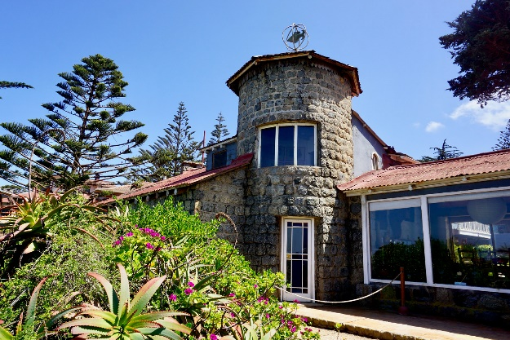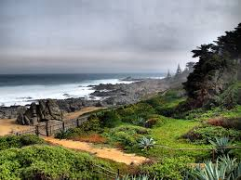

We headed towards the seaside resort of Isla Negra on the Pacific coast, refuge of the Chilean poet and Nobel Prize winner in Literature, Pablo Neruda. We visited his beautiful house museum, which houses his favorite collections, such as figureheads, bottles, navigation instruments, conch shells and many pieces of furniture he owned, which show that Neruda not only wrote poetry, but also lived poetically. Within the gardens that overlook the immensity of the Pacific Ocean is the poet's tomb next to that of Matilde Urrutia, where an intense and peaceful love story rests. The museum is a magical place and covers the history of Neruda in its entirety. In addition to Isla Negra, we will visit the typical town of Pomaire, a small town of clay artisans, where it is possible to have lunch with different dishes of typical Chilean food. Lunch not included. After this visit we return to Santiago to finish at the hotels.

**TIME: 08.30 HOURS**

**DURATION: 10 HOURS**

**INCLUDES: TRANSFER AND ENTRANCE TO THE MUSEUM**

**RESTRICTIONS: DOES NOT OPERATE ON MONDAYS**

**BAHAI TEMPLE**

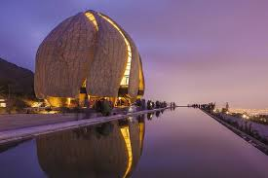 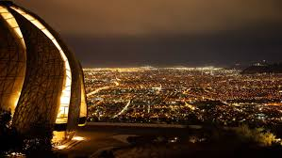 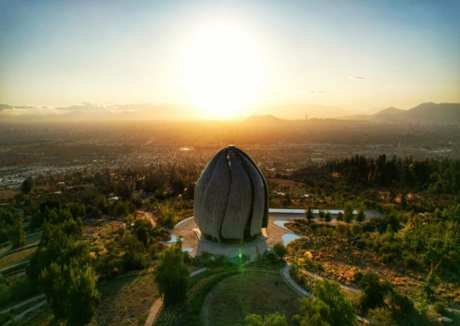

We begin our journey towards the foothills to visit this jewel of architecture, the Bahá'í House of Worship, a unique temple in South America. A place of meeting and prayer, where you visit the wonderful temple and its gardens. This House of Worship, added to those on other continents, is a meeting point that promotes unity through free participation in acts of prayer and services in a serene environment devoid of rituals or ceremonies. At the agreed time we will begin the return to the hotels.

**TIME: 09.30 OR 14.00 HRS**

**DURATION: 3 HOURS**

**INCLUDES: TRANSFER**

**RESTRICTIONS: DOES NOT OPERATE ON MONDAYS, AS IT IS CLOSED FOR MAINTENANCE**

**VIÑA SANTA RITA**

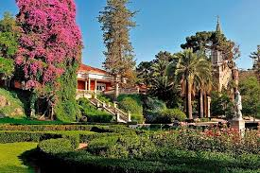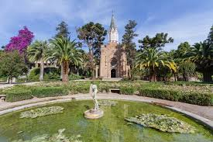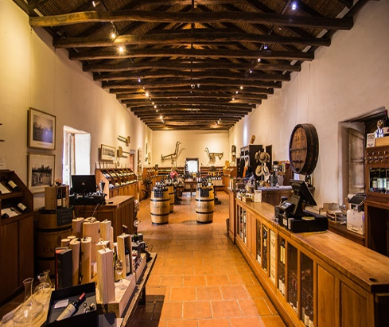

Departure to Viña Santa Rita, located in the town of Alto Jahuel, belonging to the wonderful Maipo Valley. This vineyard, founded in 1880 by Domingo Fernández Concha, has become a premium destination, due to its historical interest, and the quality of the wines they produce, since the tour contemplates the history of Chile and its viticulture. The tour will begin at the Casa del Turismo, from where you will enjoy the variety garden, to appreciate the different strains and their characteristics. You will learn about the complete winemaking process, going through the winemaking cellars, storage and bottling plant. You will visit the historic Bodega 1 made of lime and stone, in addition to the famous Bodega de los 120 Patriotas, which today is a National Monument. The tour will end with a tasting of 2 Reserva wines plus 1 Gran Reserva along with a glass as a gift. The wine store has attractive souvenirs and gourmet exclusives. We will have time to buy wines in the store and then return to the hotel.

**TIME: 09.30 OR 14.00 HRS**

**DURATION: 3 HOURS**

**INCLUDES: TRANSFER AND TASTING**

**RESTRICTIONS: NO RESTRICTIONS**

**VIÑA UNDURRAGA**

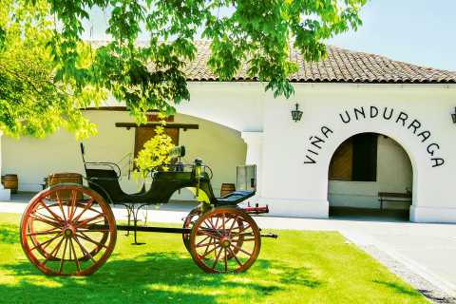 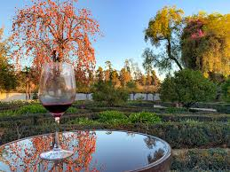 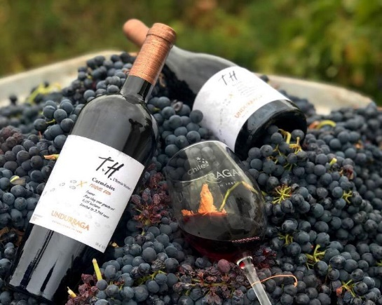

Departure to the Santa Ana Farm, where Viña Undurraga was established since its origins 135 years ago. The tour begins in the Viña Park, created by the French landscape designer George Henry Dubois, who also designed the Santiago Forest Park. Then, the visit continues to the Aliwen corner, a place where part of the vegetation typical of southern Chile is recreated and where our main indigenous people “Mapuche” are honored by exhibiting figures of their culture and making their worldview known. Following this stop, you will tour the vineyard, get to know the soils through a test pit, identify the different strains that Undurraga grows through a variety garden, and show the vinification process of the different wines. Then you will access the centuries-old underground cellars of Viña Undurraga, to finish by visiting the “People of the Earth” collection, a sample of Mapuche and pre-Columbian life and art in honor of our native peoples. The tour concludes with a tasting of 3 reserve wines. At the end, each visitor will receive a glass as a gift. Additionally, in the store you can purchase wines and sparkling wines from Undurraga brands, along with a series of entertaining souvenirs. We will have time to buy wines in the store and then return to the hotel.

**TIME: 09.30 OR 14.00 HRS**

**DURATION: 3 HOURS**

**INCLUDES: TRANSFER AND TASTING**

**RESTRICTIONS: NO RESTRICTIONS**